Alexander Baldree
3/4/2026
Module 10.1 Discussion Board
CSD340

Topic #77 – People Are Happier When They’re Busy
One of the topics that stood out to me from the reading was #77: People Are Happier When They’re Busy. The idea behind this concept is that people generally feel more satisfied when they have something to do instead of sitting idle. When users are waiting for something to load or complete on a website or application, doing nothing can make the wait feel longer and more frustrating. Designers often solve this problem by giving users something to focus on while they wait, such as animations, loading indicators, or progress bars.
Embellishment:
Something that expands on this idea is the psychological concept called “perceived progress.” When people see progress happening, even if the wait time is the same, they feel more positive about the experience. This is why many apps use animated loading screens or small interactive elements while something is processing. For example, some video games show tips, artwork, or short animations during loading screens, so the player stays mentally engaged. Even though the wait time may not actually be shorter, it feels shorter because the user’s attention is occupied.
Visual Example:
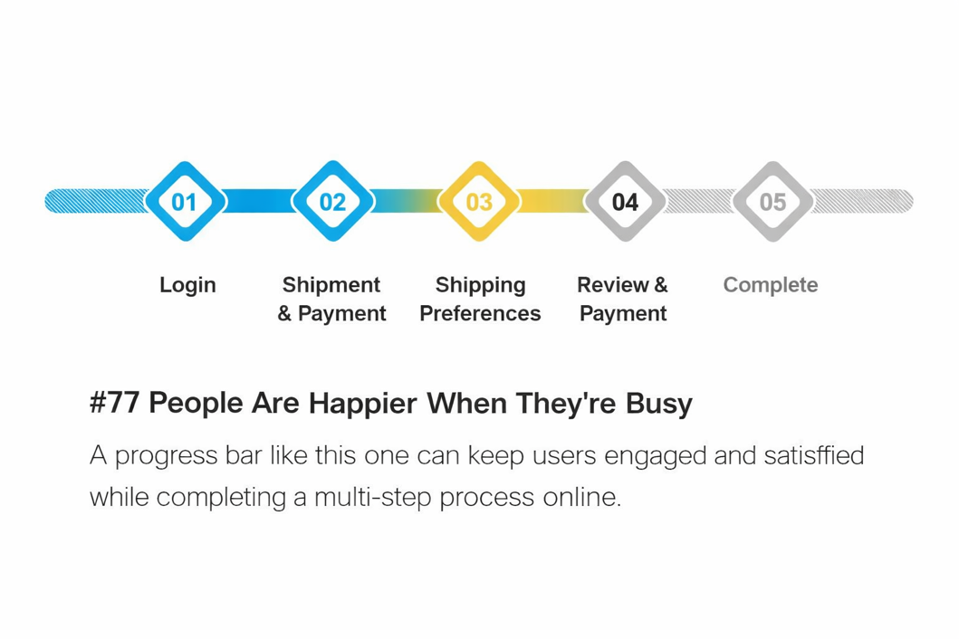

Topic #83 – People Feel More Positive Before and After an Event Than During It
Another topic I found interesting was #83: People Feel More Positive Before and After an Event Than During It. This concept explains how people often build excitement before an experience and remember it positively afterward, even if the actual moment wasn’t as enjoyable as expected. In psychology, this is related to how memory and anticipation shape emotional experiences.
Embellishment:
One interesting extension of this idea is something called the “peak-end rule.” This rule suggests that people tend to remember an experience based mainly on its most intense moment and how it ends. Because of this, designers often focus on making the beginning and ending of an experience feel rewarding. For example, websites often create excitement before an action, like a countdown before a product release or event, and then give users a satisfying confirmation or success message after completing a task.
Visual Example:
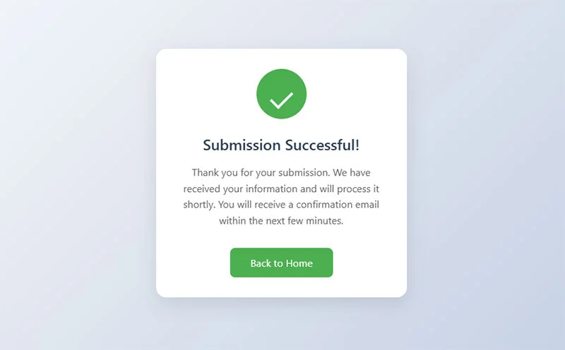
Reference:
100 Things Every Designer Needs To Know About People Susan M. Weinschenk Ph.D.
Topic 77: People Are Happier When They’re Busy Pg.175-176
Topic 83: People Feel More Positive Before And After An Event Than During It; Pg.185-186

